**Year 10 Extension Science Biology End of Topic Test 2014**

**Name:_____________________________________**

1. How many chromosomes are contained by each human egg or sperm?

a) 23 chromosomes

b) 46 chromosomes

c) 23 pairs of chromosomes

d) a diploid number of chromosomes

2 The gametes of a fruit fly have four chromosomes. What is the diploid number of chromosomes for the fruit fly?

a) 2

b) 4

c) 6

d) 8

3 The structure of DNA may be described as a twisted ladder. What substances form the upright parts of the ladder?

a) alternating sugar and phosphate units

b) nitrogen bases

c) amino acids

d) protein

4 What is the number of chromosomes in cells after meiosis, compared to the original cell?

a) double

b) same

c) half

d) quarter

5 Alanna wants to examine gamete formation. What the most suitable prepared slide for her to examine?

a) human skin

b) rat testes

c) early developing embryo

d) human bone marrow

6 When is the sex of an individual determined?

a) when the egg is formed

b) when the sperm is formed

c) when the egg is fertilised by the sperm

d) when the embryo is 12 weeks old

7 Mitosis results in the production of two cells that are:

a) decidedly smaller with fewer organelles

b) genetically identical to the gametes

c) genetically identical to the parent cell

d) have the same function but genetically different

8 Where are chromosomes are found?

a) in the nucleus of most cells of your body

b) in the nucleus of brain cells only

c) in the nucleus of reproductive cells only

d) in the nucleus of stem cells that have not yet differentiated

9 Most cells in your body contain two of each type of chromosome (i.e. they have 2N chromosomes). What is the exception to this?

a) diploid cells

b) body cells

c) gametes

d) homologous cells

10 The pedigree below shows a recessive inherited condition, which is indicated by the yellow colour. Male parent 2 has the condition but his female partner does not. Identify the correct statement for their children.

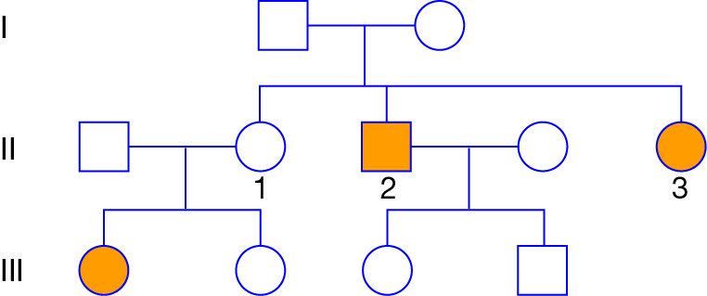

a) Their children are carriers of the condition.

b) Their children are homozygous dominant for the condition.

c) Their children will not have children with the condition.

d) Their children are homozygous recessive for the condition.

11 Choose the correct term for the following definition: ‘Genetic change in the characteristics of a species over many generations, resulting in the formation of new species.’

a) natural selection

b) evolution

c) adaptation

d) mutation

12 Characteristics of an organism that have the same basic structure are:

a) mutations

b) adaptations

c) homologous

d) variations

13 Which of the following should be an outcome of natural selection?

a) a species gradually becomes better adapted to its environment

b) variations will appear in the offspring

c) mutations gradually disappear because they are harmful

d) species gradually become less adapted to their environment

14 A modern definition of natural selection taking into account genetics is:

a) the fittest individuals survive and become more adapted during their lives

b) selective agents act on the phenotypes in a population and change the proportion of particular genes

c) selection pressure on the better adapted genotypes improves their survival

d) the environment selects a particular species to survive by natural means

15 The number and range of different species that exist on Earth is referred to as:

a) geodiversity

b) genotype

c) biodiversity

d) mutation

16 Genetic isolation refers to:

a) keeping potentially interbreeding groups apart by some barrier or mechanism

b) changing the genes in a species by a process of natural selection

c) mutation permanently preventing an individual from breeding

d) a chemical technique used to remove genes during genetic profiling

17 A sudden random change in genotype is called:

a) Phenotype

b) Genetic Modification

c) Phylogeny

d) Mutation

18 Charles Darwin was famous for:

a) defining the term evolution

b) suggesting natural selection was the mechanism of evolution

c) writing a book called ‘The Origin of Species’ that showed how natural selection resulted from evolution

d) inventing the term artificial selection and proposing that it caused evolution

19 Darwin proposed that variation was critical in understanding how species change over long periods of time. His argument was that:

a) isolation and variation result from natural selection

b) selection relies on there being as little variation as possible within a population

c) genetic variation depends solely on mutation

d) selection cannot occur without differences in a population

20 Homologous features:

a) can be found in species that are not related to each other

b) are used in the same way in different species

c) do not have to have the same function in all species

d) may be the result of adaptation of distantly related species to similar environments

**END OF MULTIPLE CHOICE**

**Short Answer Section**

1. The pedigree below shows the generations of a particular breeding group. The shaded individuals are suffering from a condition known as "gingervitis" which causes soullessness and extreme fear of the sun.

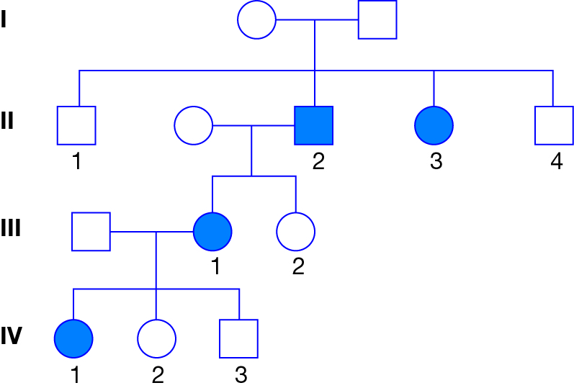

a) Determine whether gingervitis is dominant or recessive:_____________________________ (1)

b) Provide reasoning and proof from the pedigree for your answer for part a:

__________________________________________________________________________________

__________________________________________________________________________________

__________________________________________________________________________________

______________________________________________________________________________ (2)

2. Half of a strand of DNA bases is shown below. Write the complementary DNA strand inthe space provided below it.

A C G T C A A T G C A T G

_ _ _ _ _ _ _ _ _ _ _ _ _

(1)

3. In the space provided write either the definition or the word associated with the definition (correctly spelt).

|  |  |
| --- | --- |
| **Word** | **Definition** |
|  | A trait that masks/hides another trait |
|  | The physical appearance of a gene |
|  | The process by which a new species is formed |
| Natural Selection |  |
|  | DNA base that pairs with cytosine |
| Allele |  |
| Haploid |  |

(7)

4. Identify and state the major differences between mitosis and meiosis.

__________________________________________________________________________________

__________________________________________________________________________________

__________________________________________________________________________________

__________________________________________________________________________________

__________________________________________________________________________________

__________________________________________________________________________________

__________________________________________________________________________________

__________________________________________________________________________________

__________________________________________________________________________________

(4)

5. State and describe the four (4) steps to speciation.

__________________________________________________________________________________

__________________________________________________________________________________

__________________________________________________________________________________

__________________________________________________________________________________

__________________________________________________________________________________

__________________________________________________________________________________

__________________________________________________________________________________

__________________________________________________________________________________

__________________________________________________________________________________

__________________________________________________________________________________

__________________________________________________________________________________

__________________________________________________________________________________

__________________________________________________________________________________

__________________________________________________________________________________

__________________________________________________________________________________

__________________________________________________________________________________

__________________________________________________________________________________

________________________________________________________________________________(8)

6. Explain why variation is necessary before natural selection can occur.

__________________________________________________________________________________

__________________________________________________________________________________

__________________________________________________________________________________

__________________________________________________________________________________

__________________________________________________________________________________

__________________________________________________________________________________

__________________________________________________________________________________

__________________________________________________________________________________

__________________________________________________________________________________

__________________________________________________________________________________

__________________________________________________________________________________

(3)

7. On the diagram below identify four (4) areas of the human body that required changing from an ape's body for humans to become bipedal. You must also specify how the structure has changed to accommodate bipeadalism.

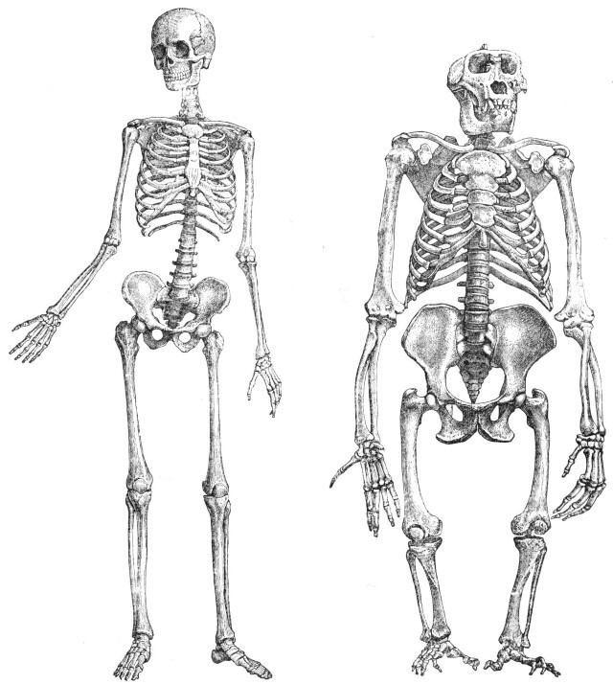(8)